What saith the Lord concerning the direction of the winds?

Exodus 10:13
And Moses stretched forth his rod over the land of Egypt, and the LORD brought an east wind upon the land all that day, and all that night; and when it was morning, the east wind brought the locusts.
Exodus 10:19
And the LORD turned a mighty strong west wind, which took away the locusts, and cast them into the Red sea; there remained not one locust in all the coasts of Egypt.

No matter how you look at it the Red Sea is East of Egypt. And since it was a “west wind” that blew the locusts from the 8th plague from Egypt into the Red Sea we know also that when the Bible says “west wind” we can read it much the same as we still use those phrases today as “from the west, to the east”.

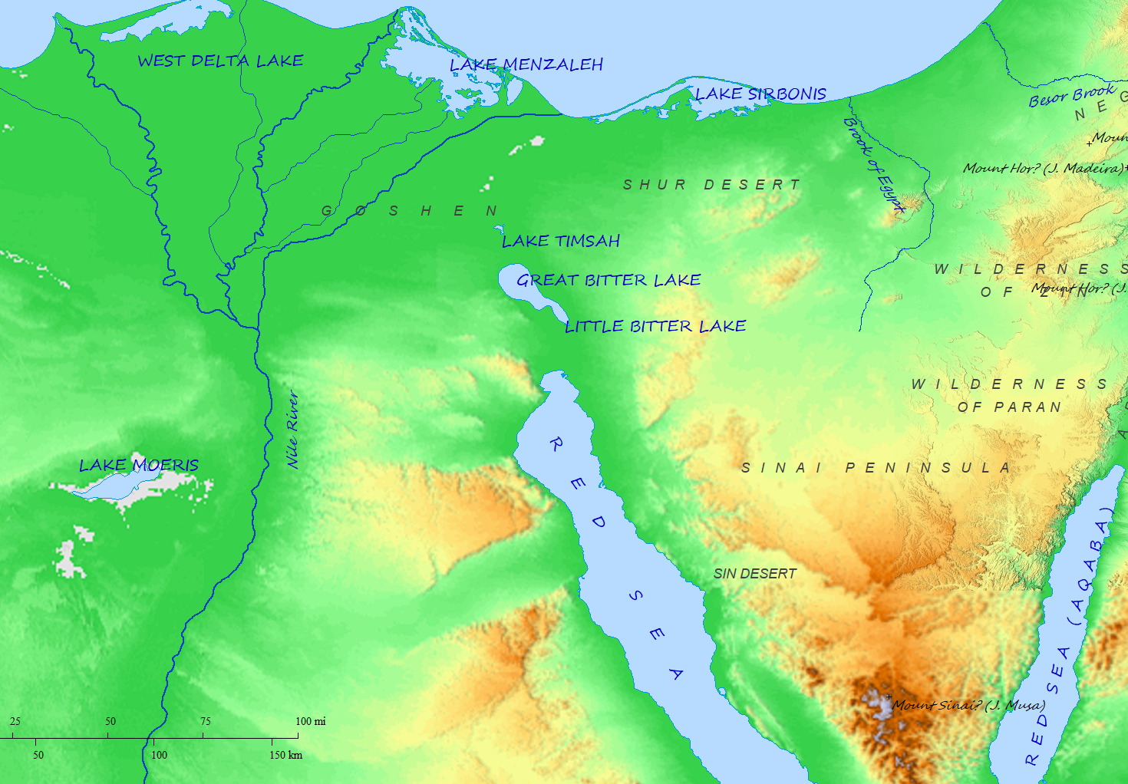Biblemapper 3.0

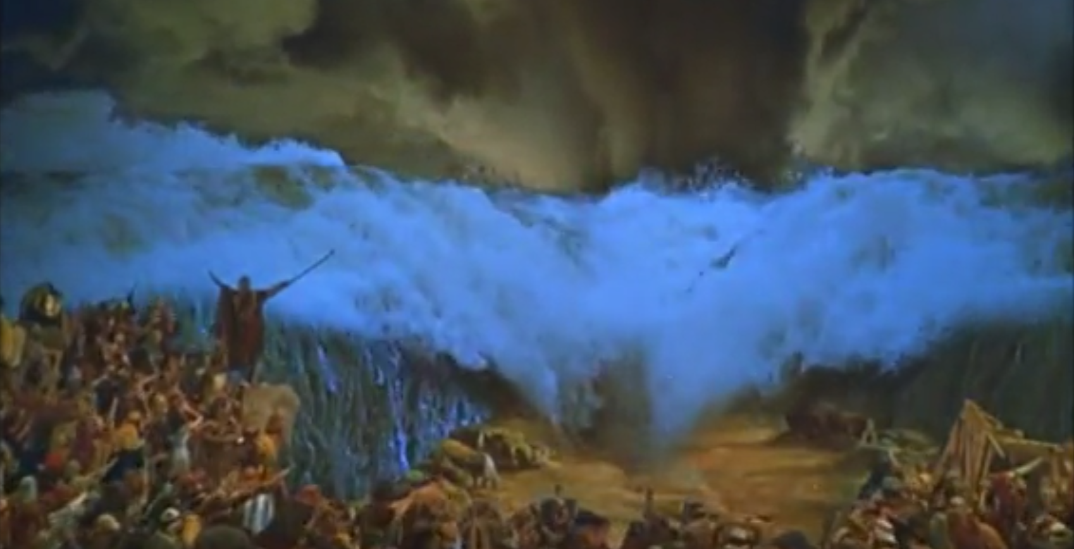The Ten Commandments, 1956, 3:08:48

In the 1956 film “The Ten Commandments” directed by Cecil B. Demille, the wind is depicted as coming from Moses’ back which would be a “west wind” (from the west, heading eastward). But, the Bible says the exact opposite:

Exodus 14:21
And Moses stretched out his hand over the sea; and the LORD caused the sea to go back by a strong east wind all that night, and made the sea dry land, and the waters were divided.

As we saw above, an “east wind” in the Bible is very clearly the same as “from the east, headed westward.”

Now let’s apply what we learned to scripture itself instead of discerning truth from error.

Numbers 11:31
And there went forth a wind from the LORD, and brought quails from the sea, and let them fall by the camp, as it were a day's journey on this side, and as it were a day's journey on the other side, round about the camp, and as it were two cubits high upon the face of the earth.

No direction is given here; but, we know from geography that the sea was to the south of where the children of Israel were encamped. How would we know that if we didn’t know the geography and how can we prove that with scripture (1Thess 5:21)?

Psalms 78:26-72
26 He caused an east wind to blow in the heaven: and by his power he brought in the south wind.
27 He rained flesh also upon them as dust, and feathered fowls like as the sand of the sea:
28 And he let it fall in the midst of their camp, round about their habitations.
29 So they did eat, and were well filled: for he gave them their own desire;
30 They were not estranged from their lust. But while their meat was yet in their mouths,
31 The wrath of God came upon them, and slew the fattest of them, and smote down the chosen men of Israel.
- The “east wind” is the parting of the Red Sea.
- The “south wind” brought the quails from the south northward to the children of Israel’s encampment.

